Manav Rachna International Institute of
Research and Studies
School of Computer Applications
PRACTICAL FILE
of
DATA STRUCTURE & ALGORITHM

Master of Computer Applications (MCA) – Semester 1
Academic Session 2026–2027
SUBMITTED BY
Name : Pawan
Roll No. : 26MCAP101N020
Course : MCA, Semester 1
SUBMITTED TO
Dr. Sachin Sharma
Assistant Professor
School of Computer Applications(MRIIRS)

Practical 1: Basic List Operations

Aim
To write a menu-driven Python program that performs insertion, deletion and display operations on a list, and handles empty lists and invalid positions safely.

Algorithm
- Create an empty list data and display the menu.
- Read the user's choice. If it is not an integer, report an error and read it again.
- Insert at end: read a value and append it to data.
- Insert at position: read the position and the value. If 0 ≤ position ≤ length, insert the value at that position; otherwise report an invalid position.
- Delete by position: if the list is empty, report it. Otherwise, if 0 ≤ position < length, remove the element at that position; else report an invalid position.
- Delete by value: if the list is empty, report it. Otherwise remove the first occurrence of the value, or report that the value was not found.
- Display: print the list and its size, or report that the list is empty.
- Repeat steps 2 to 7 until the user chooses Exit.
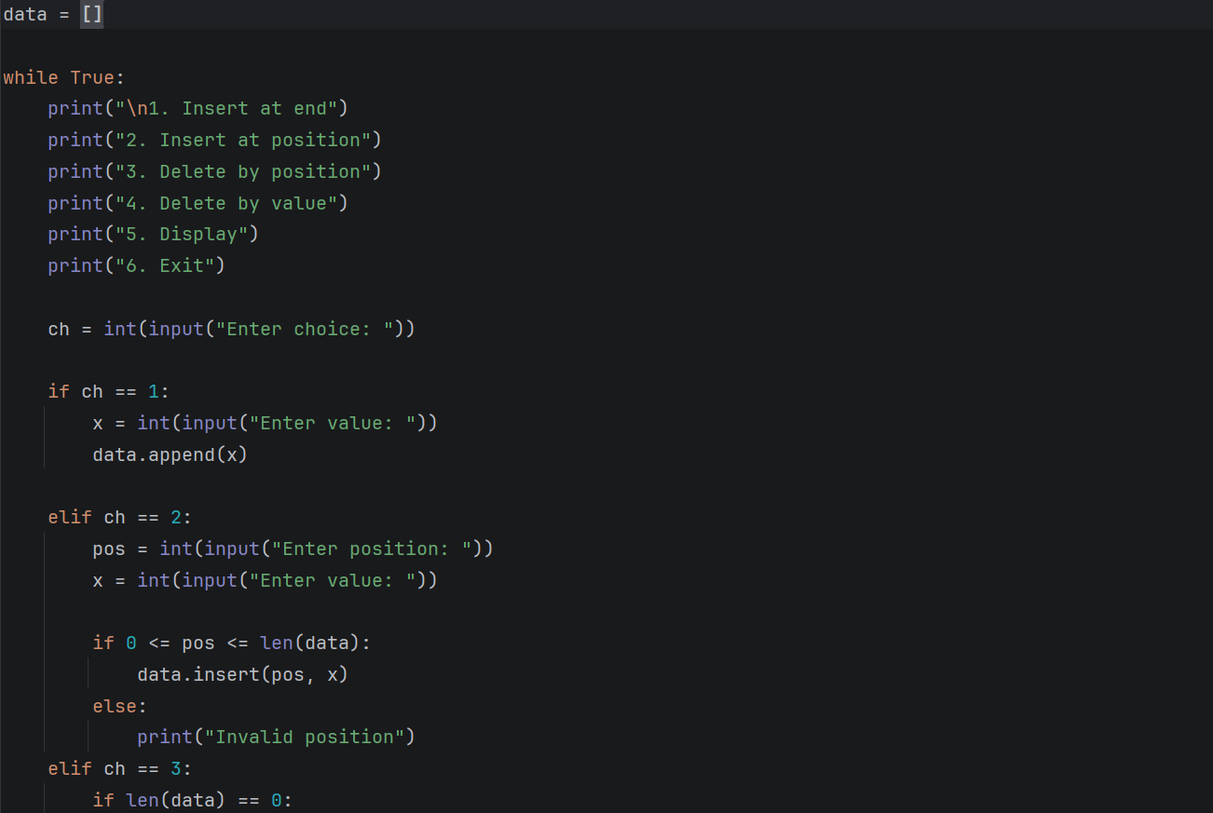

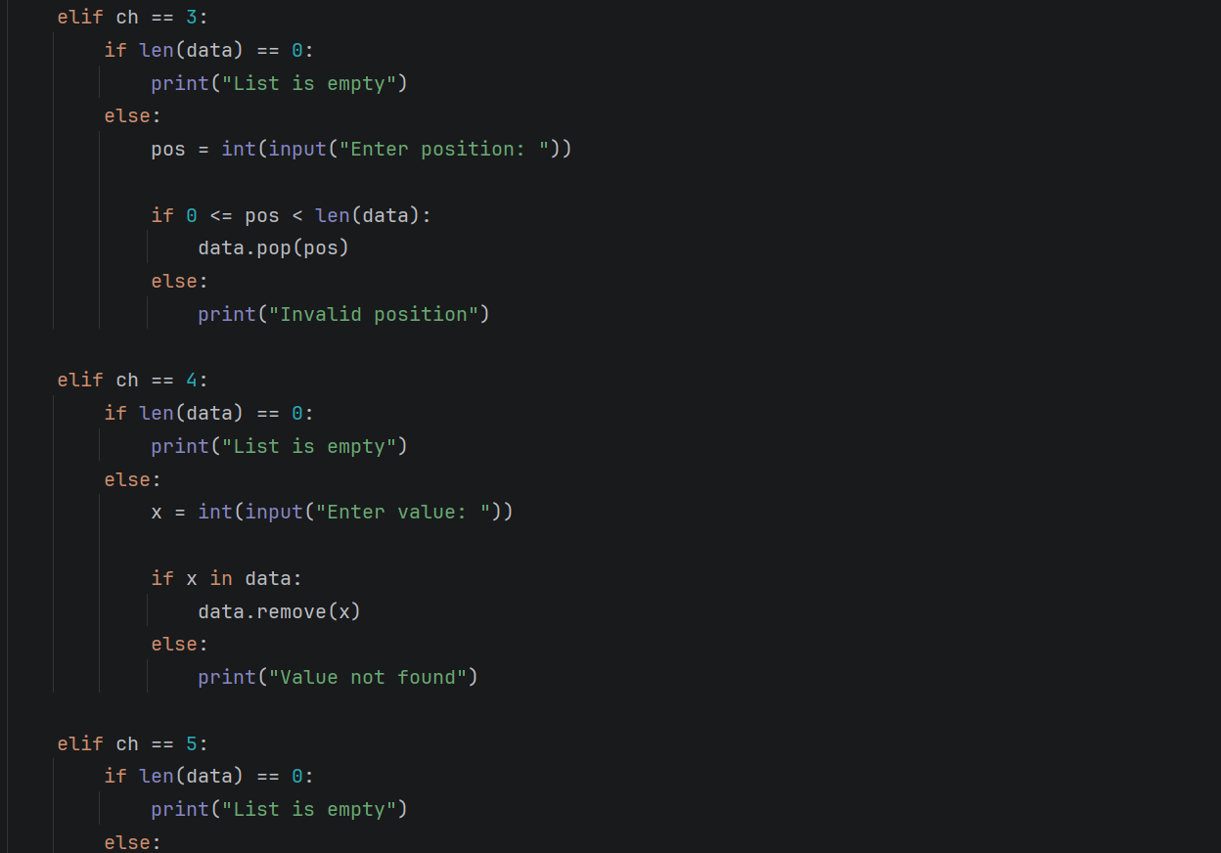
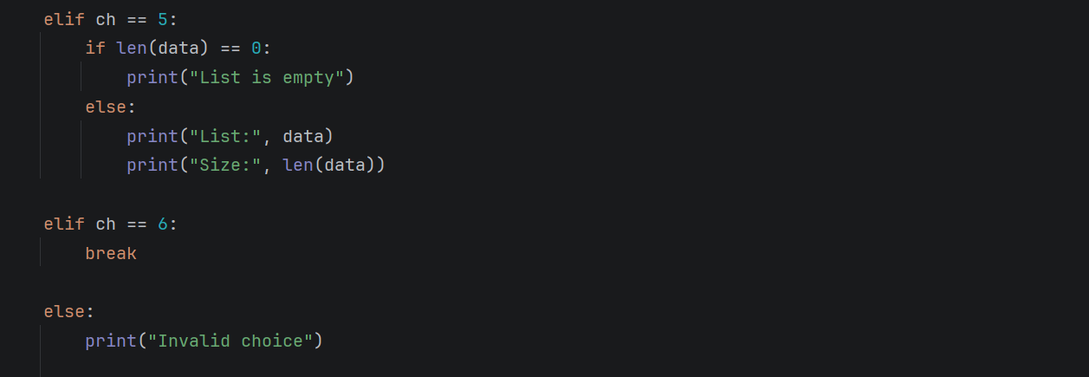

Output:
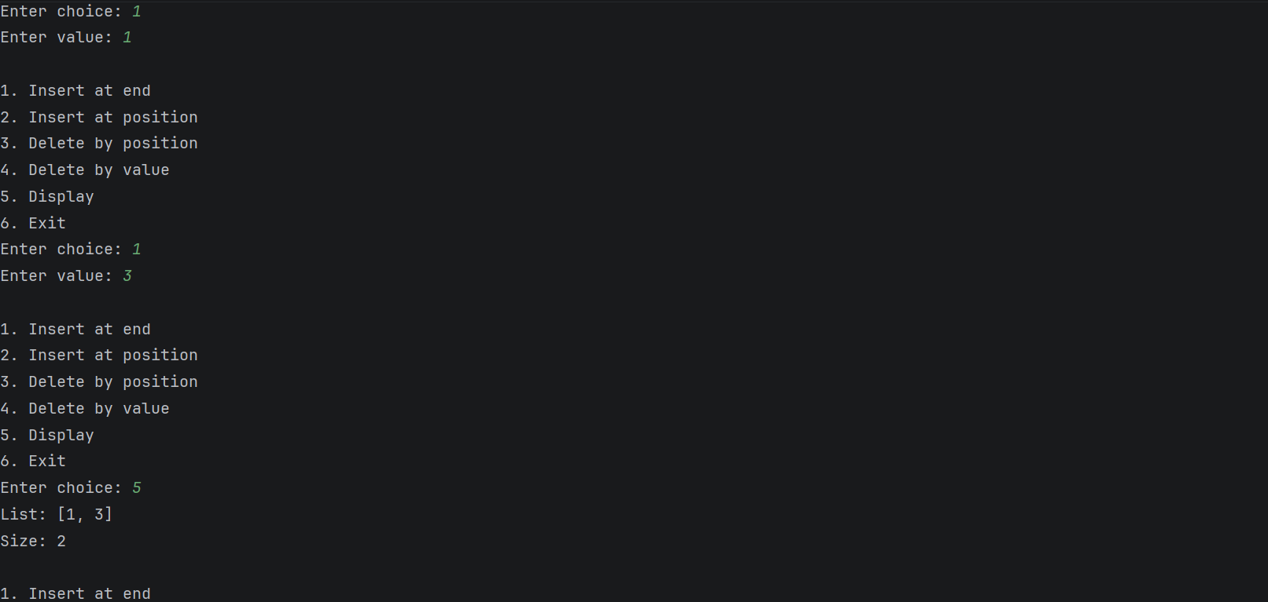

Practical 2: Quick Sort and Merge Sort

Aim
To write a Python program that sorts a list using Quick Sort and Merge Sort, implemented manually, and to compare their time complexities.

Algorithm

Quick Sort (in place)
- If low < high, partition arr[low..high] and obtain the pivot position p.
- Partition: take pivot = arr[high] and set i = low - 1. For j from low to high - 1, if arr[j] ≤ pivot, increase i by 1 and swap arr[i] with arr[j].
- Swap arr[i + 1] with arr[high] and return i + 1 as p.
- Recursively sort arr[low..p - 1] and arr[p + 1..high].

Merge Sort
- If the list has one element or none, return a copy of it.
- Split the list at the middle index into a left half and a right half and sort each half recursively.
- Merge: with i = j = 0, repeatedly compare left[i] and right[j], append the smaller one to the result and advance its index, until one half is exhausted.
- Append the remaining elements of the other half and return the merged list.

Main program
- Read the numbers, copy the list, sort one copy with Quick Sort and sort the original with Merge Sort.
- Display the original list and both sorted results, then measure the running time of both methods for a random list and for an already sorted list.

Python Program
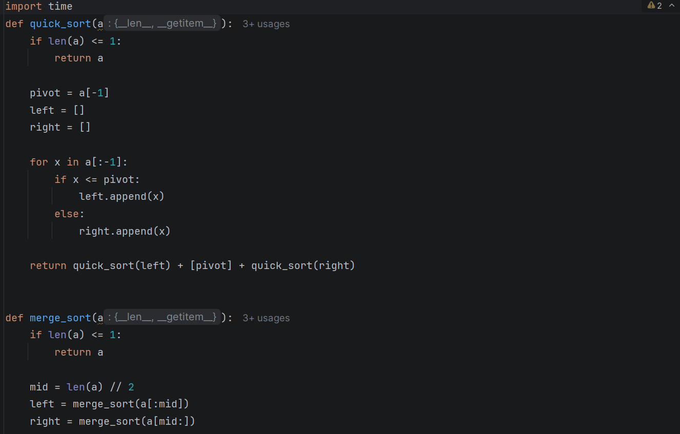
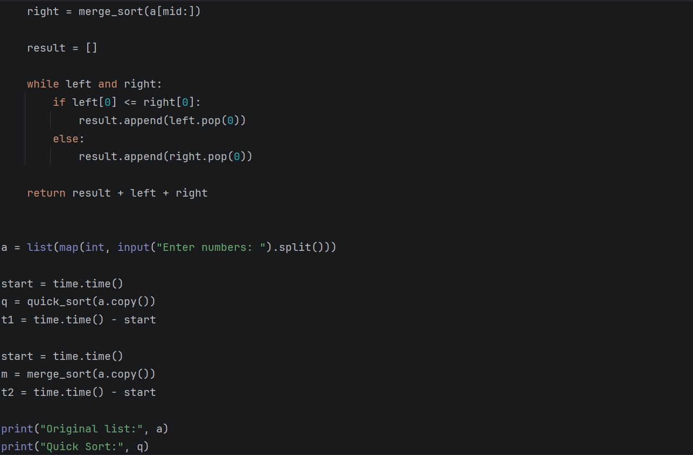

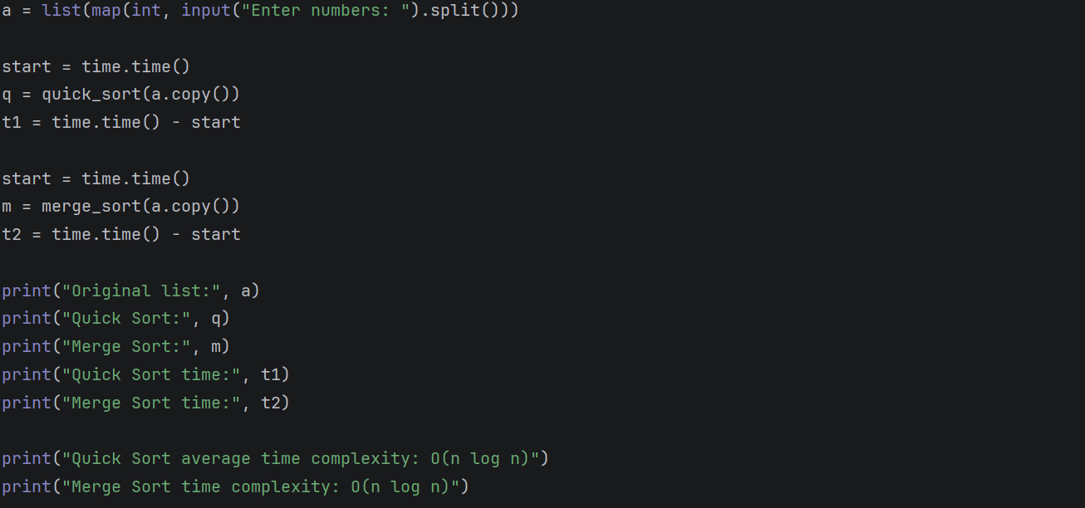

Output:
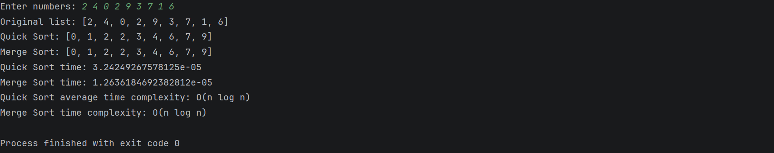

Practical 3: Array-Based Stack, Queue, Circular Queue and Browser History

Aim
To implement a stack, a queue, a circular queue and a browser history (using two stacks) with arrays.

Algorithm

A. Stack using an array (top = -1 initially)
- Push: if top = capacity - 1, report Stack Overflow; otherwise increase top by 1 and store the item at data[top].
- Pop: if top = -1, report Stack Underflow; otherwise read data[top], decrease top by 1 and return the item.
- Peek: if top = -1, report Stack Underflow; otherwise return data[top].
- Display: print data[top], data[top - 1], ..., data[0].

B. Queue using an array (front = 0, rear = -1 initially)
- Enqueue: if rear = capacity - 1, report Queue Overflow; otherwise increase rear by 1 and store the item at data[rear].
- Dequeue: if front > rear, report Queue Underflow; otherwise read data[front], increase front by 1 and return the item.
- Front element: if front > rear, report Queue Underflow; otherwise return data[front].
- Display: print data[front] to data[rear].

C. Circular queue using an array (front = 0, size = 0 initially)
- Enqueue: if size = capacity, report Queue Overflow; otherwise store the item at index (front + size) mod capacity and increase size by 1.
- Dequeue: if size = 0, report Queue Underflow; otherwise read data[front], set front = (front + 1) mod capacity, decrease size by 1 and return the item.
- Front element: if size = 0, report Queue Underflow; otherwise return data[front].
- Display: for i from 0 to size - 1, print data[(front + i) mod capacity].

D. Browser history using two stacks (current = None initially)
- Visit: if a current page exists, push it onto the backward stack; set current to the new page and clear the forward stack.
- Back: if the backward stack is empty, report that there is no previous page; otherwise push the current page onto the forward stack and pop the backward stack into current.
- Forward: if the forward stack is empty, report that there is no forward page; otherwise push the current page onto the backward stack and pop the forward stack into current.
- Display: print the current page (and the contents of both stacks).

Python Program
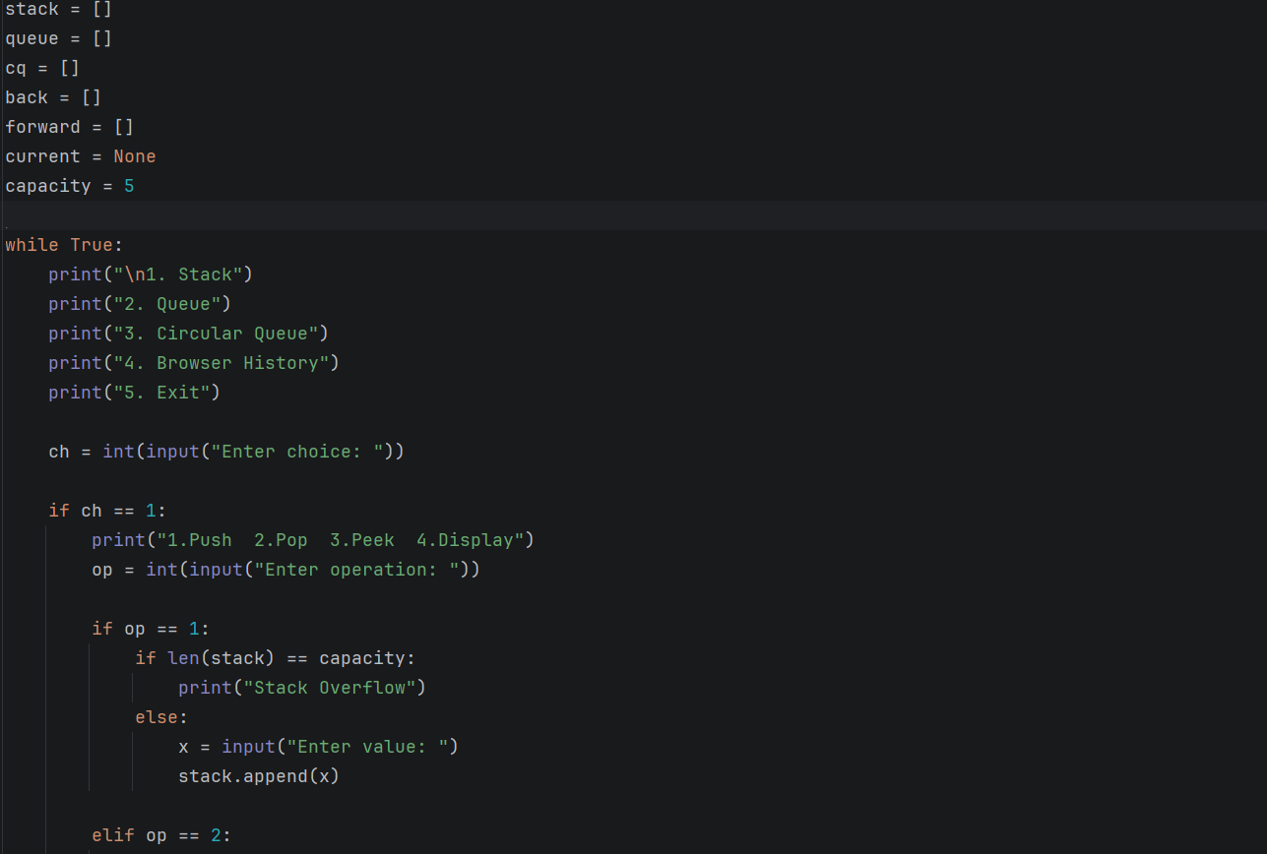

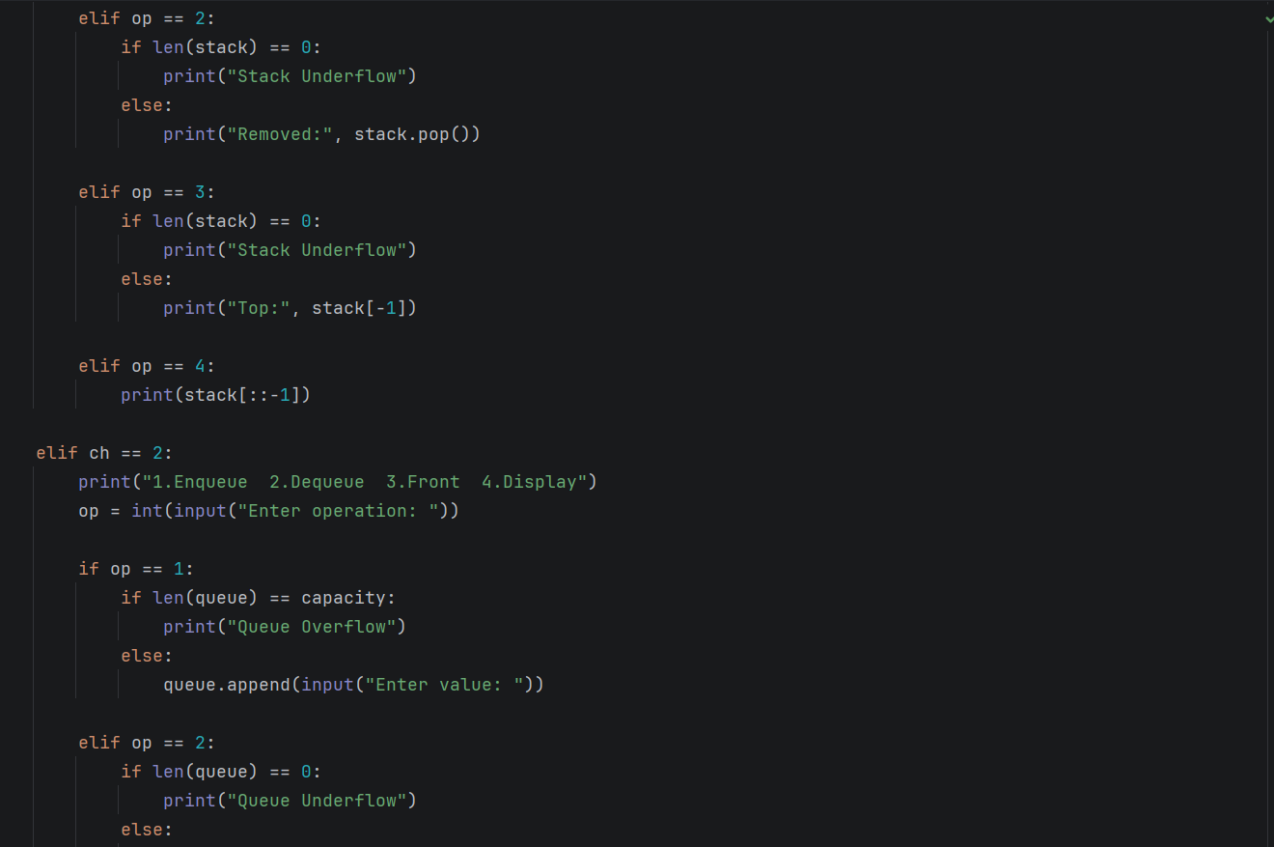

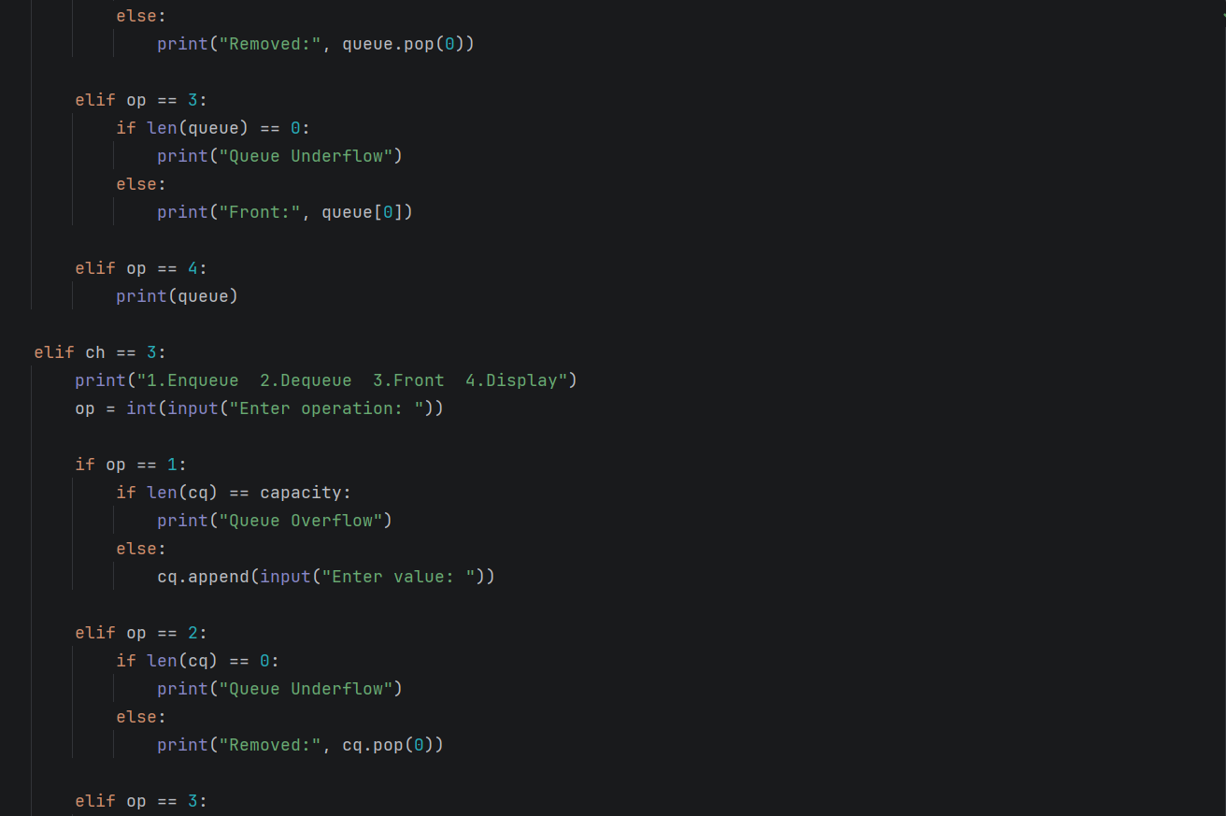

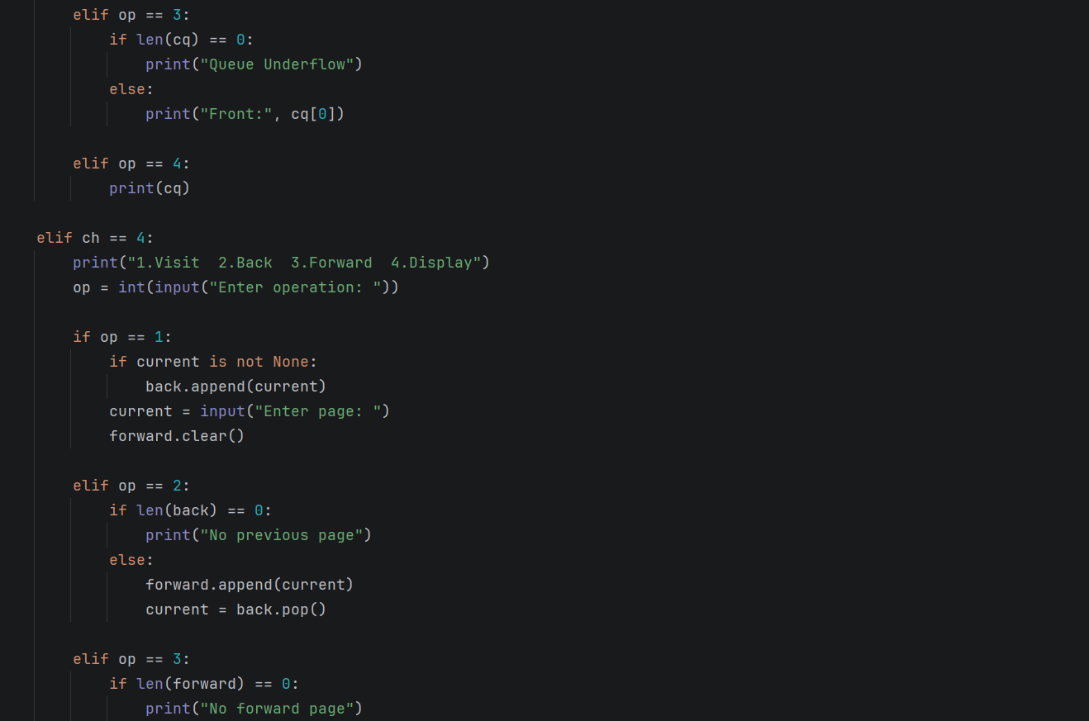

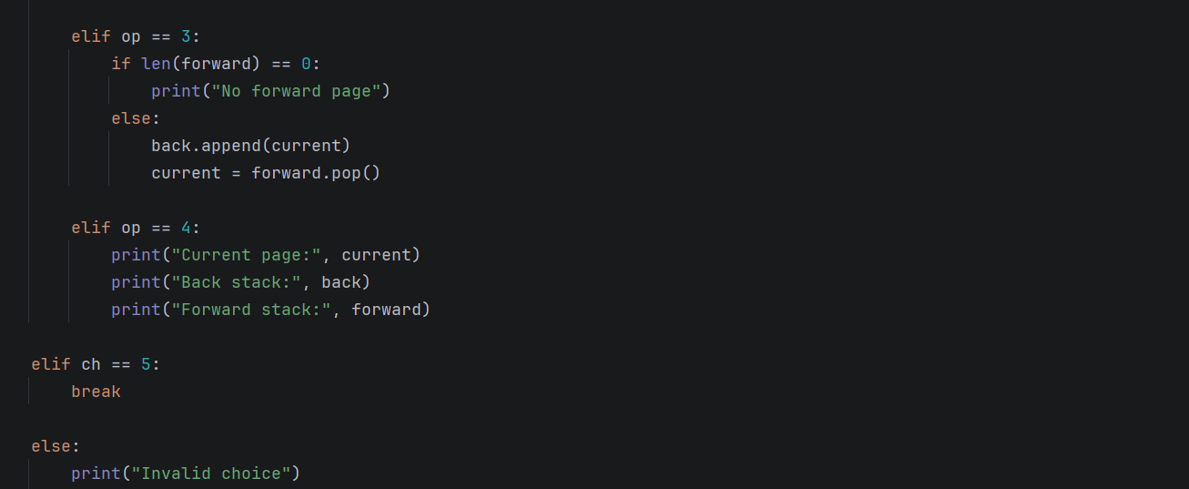

Output:

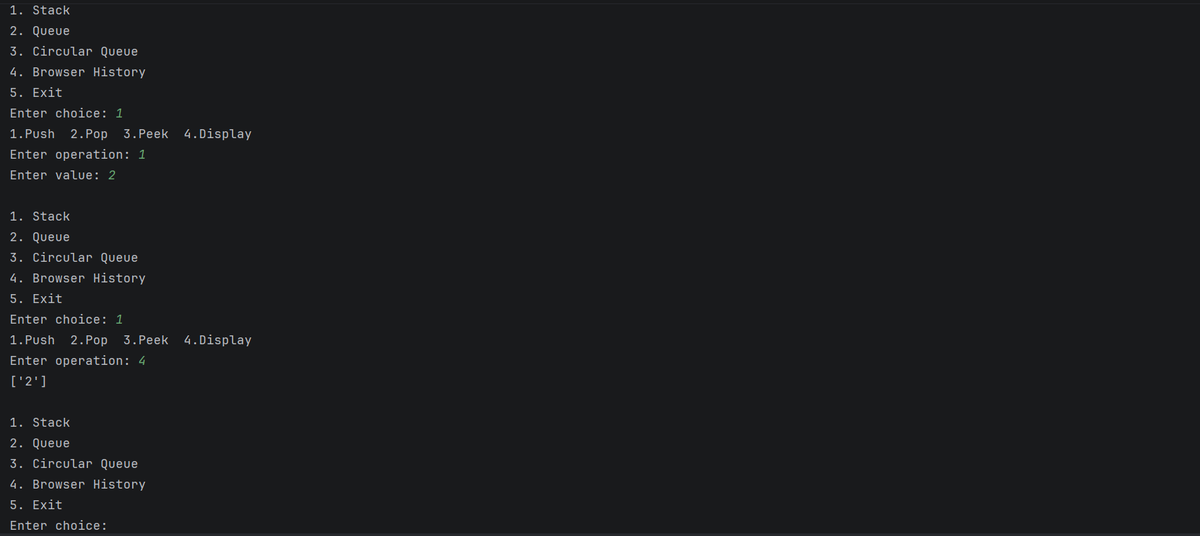

Practical 4: Postfix Expression Evaluation
Aim
To write a Python program that evaluates a postfix expression using a stack.

Algorithm
- Create an empty stack and split the expression into tokens using whitespace. If there are no tokens, report an error.
- Read the next token from left to right.
- If the token is an integer, push it onto the stack.
- If the token is an operator, check that the stack holds at least two values; otherwise report an invalid expression.
- Pop the stack to obtain the right operand, then pop it again to obtain the left operand.
- Apply the operator as left operator right. If the operator is / and the right operand is 0, report division by zero.
- Push the result onto the stack.
- If the token is neither an integer nor an operator, report an invalid token.
- Repeat steps 2 to 8 for all tokens.
- If exactly one value remains on the stack, display it as the result; otherwise report that the expression has too many operands.

Python Program
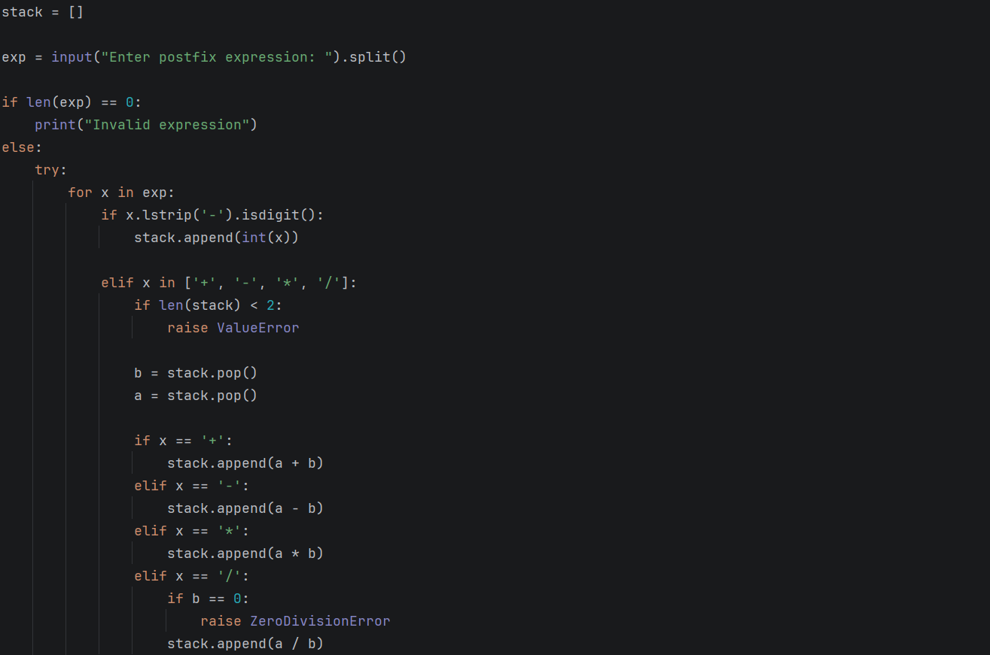
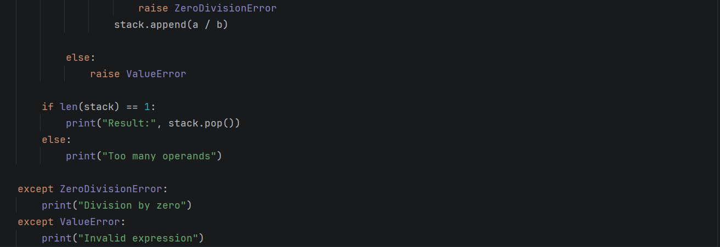

Output:
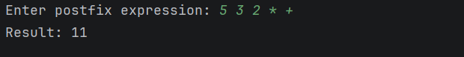

Practical 5: Infix-to-Postfix Conversion

Aim
To write a Python program that converts an infix expression into postfix notation using a stack.

Algorithm
- Tokenize the expression and check that operands and operators are in a valid order. Create an empty operator stack and an empty output list.
- Read the next token from left to right.
- If the token is an operand, append it to the output.
- If the token is (, push it onto the stack.
- If the token is ), pop operators from the stack to the output until ( is found, and discard the (. If no ( is found, report mismatched parentheses.
- If the token is an operator o1, repeatedly pop the operator o2 at the top of the stack to the output while o2 is not ( and either o2 has higher precedence than o1, or o2 has equal precedence and o1 is left-associative. Then push o1.
- Repeat steps 2 to 6 for all tokens.
- Pop all remaining operators from the stack to the output. If a ( is found, report mismatched parentheses.
- The output list, joined with spaces, is the postfix expression.

Python Program
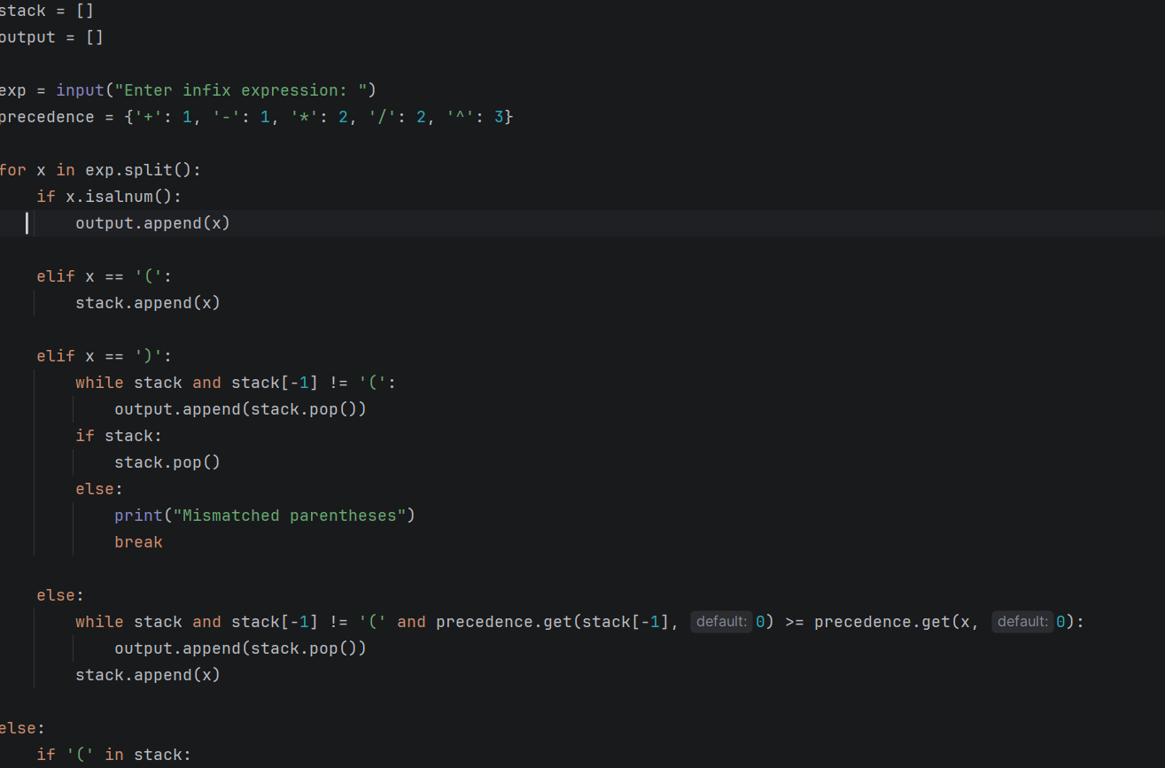

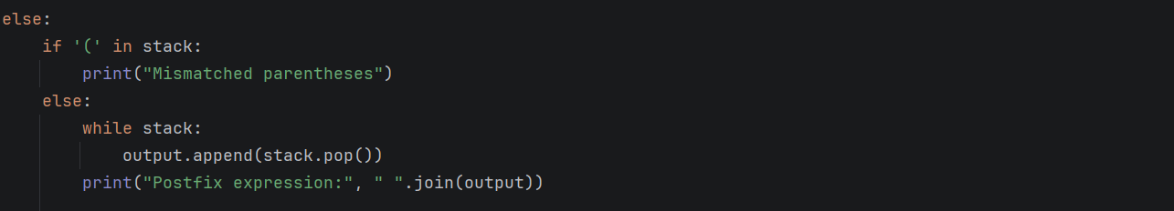

Output:
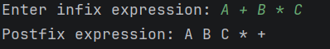

Practical 6: Singly Linked List Operations

Aim
To write a Python program that performs insertion, deletion and display operations on a singly linked list.

Algorithm
- Create an empty list with head = None.
- Insert at beginning: create a new node, set its next to head and set head to the new node.
- Insert at end: create a new node. If the list is empty, make it the head. Otherwise traverse to the last node (the node whose next is None) and set its next to the new node.
- Delete by value: if the list is empty, report it. If the head holds the value, set head = head.next. Otherwise traverse with a reference previous; when previous.next holds the value, set previous.next = previous.next.next. If the end is reached, report that the value was not found.
- Display: if the list is empty, report it; otherwise traverse from head, printing each value followed by an arrow, and finish with None.

Python Program
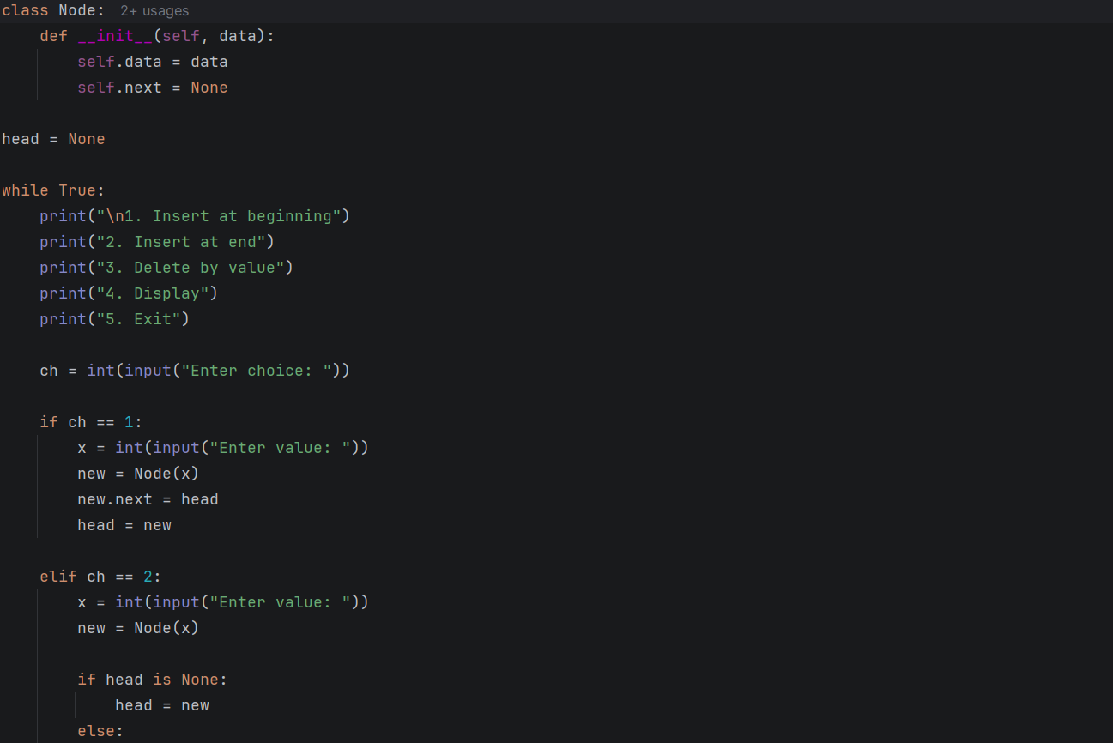

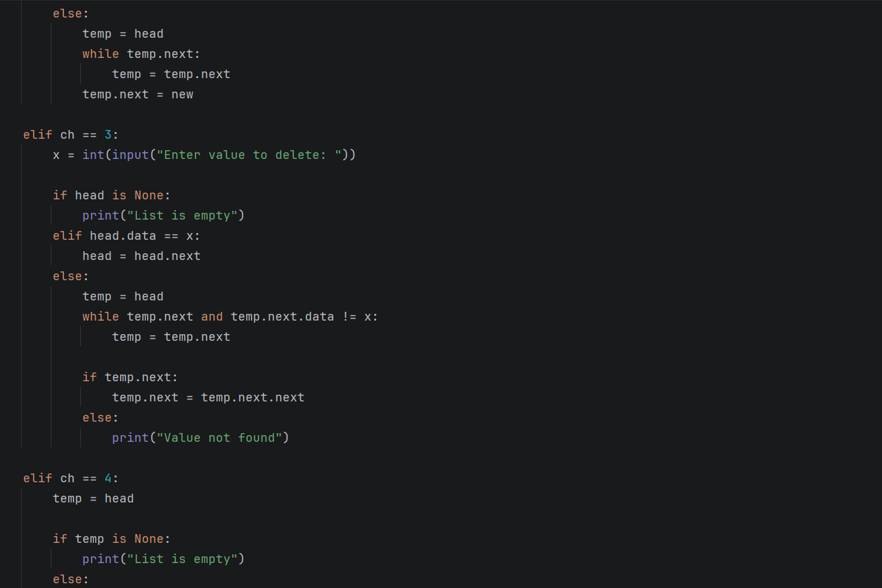

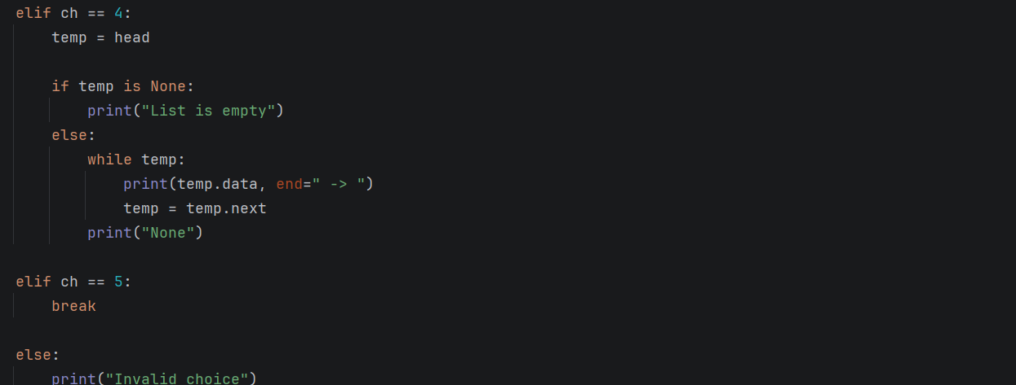

Output:
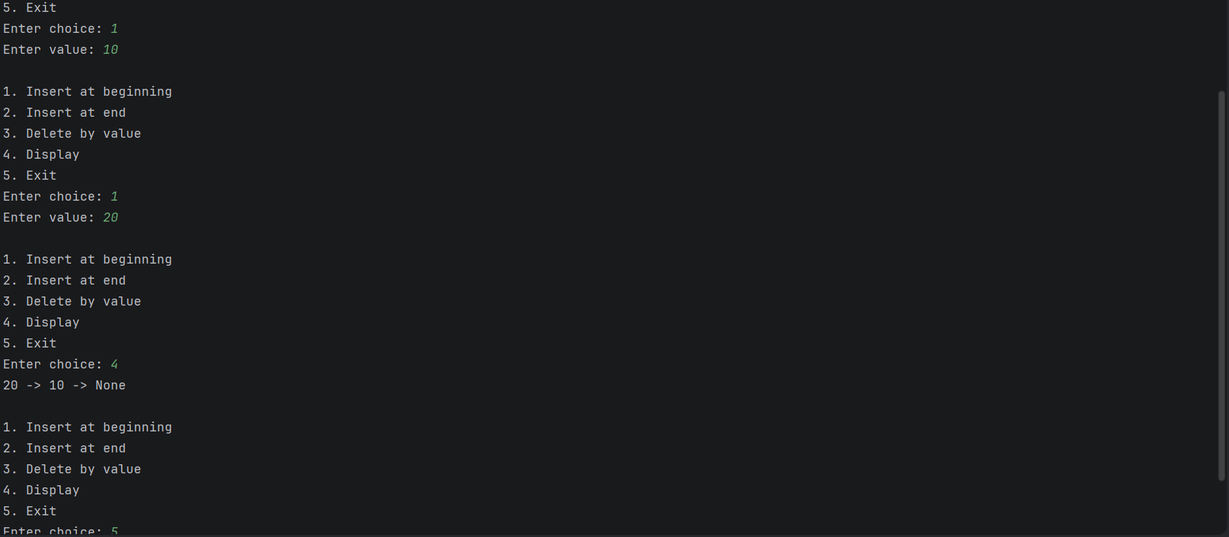

Practical 7: Circular Linked List Operations

Aim
To write a Python program that performs insertion, deletion and display operations on a circular singly linked list.

Algorithm
- Create an empty list with last = None.
- Insert at beginning: create a node. If the list is empty, set node.next = node and last = node. Otherwise set node.next = last.next and last.next = node.
- Insert at end: create a node. If the list is empty, set node.next = node. Otherwise set node.next = last.next and last.next = node. In both cases set last = node.
- Delete by value: if the list is empty, report it. Start with previous = last and current = head. If current holds the value: if it is the only node, set last = None; otherwise set previous.next = current.next, and if current was last, set last = previous.
- If the value is not found, move previous and current forward and continue. If current returns to the head, one full circle is complete and the value is reported as not found.
- Display: if the list is empty, report it. Otherwise print each node from the head, stop when the head is reached again, and show that the last node points back to the head.

Python Program
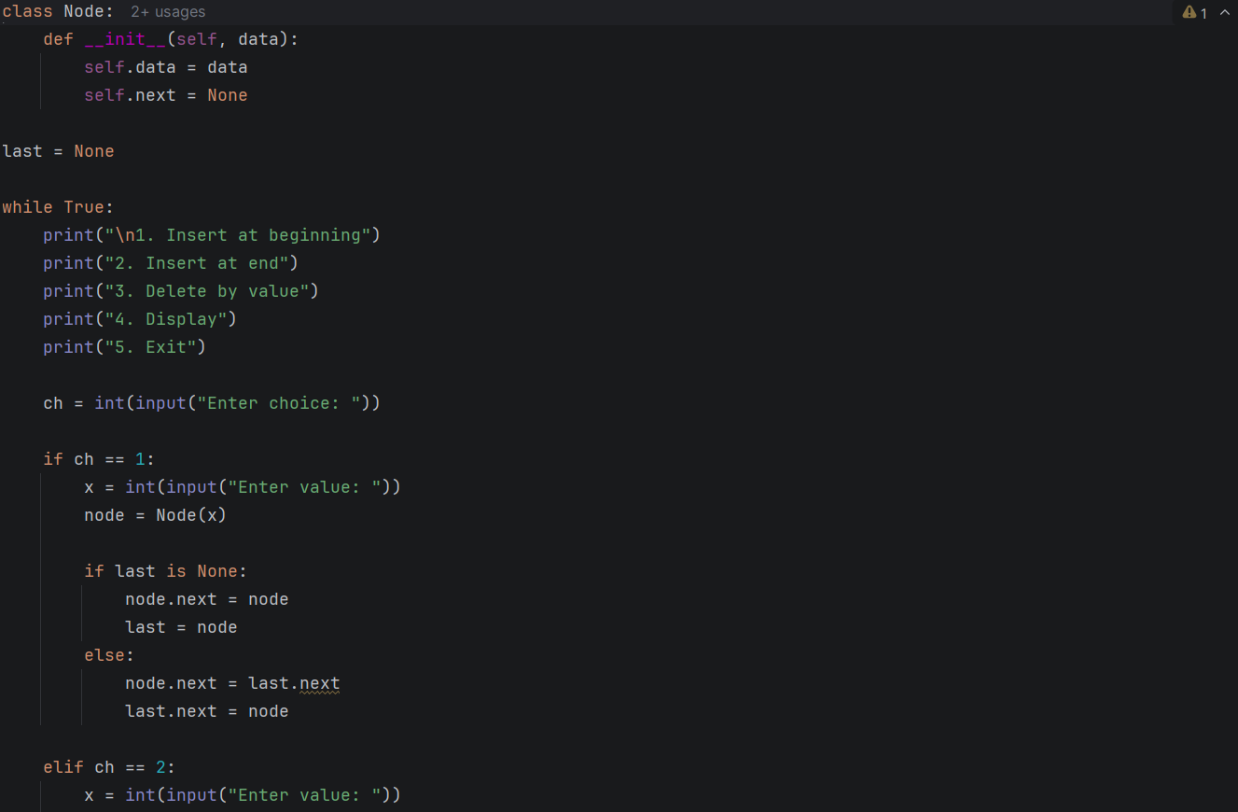
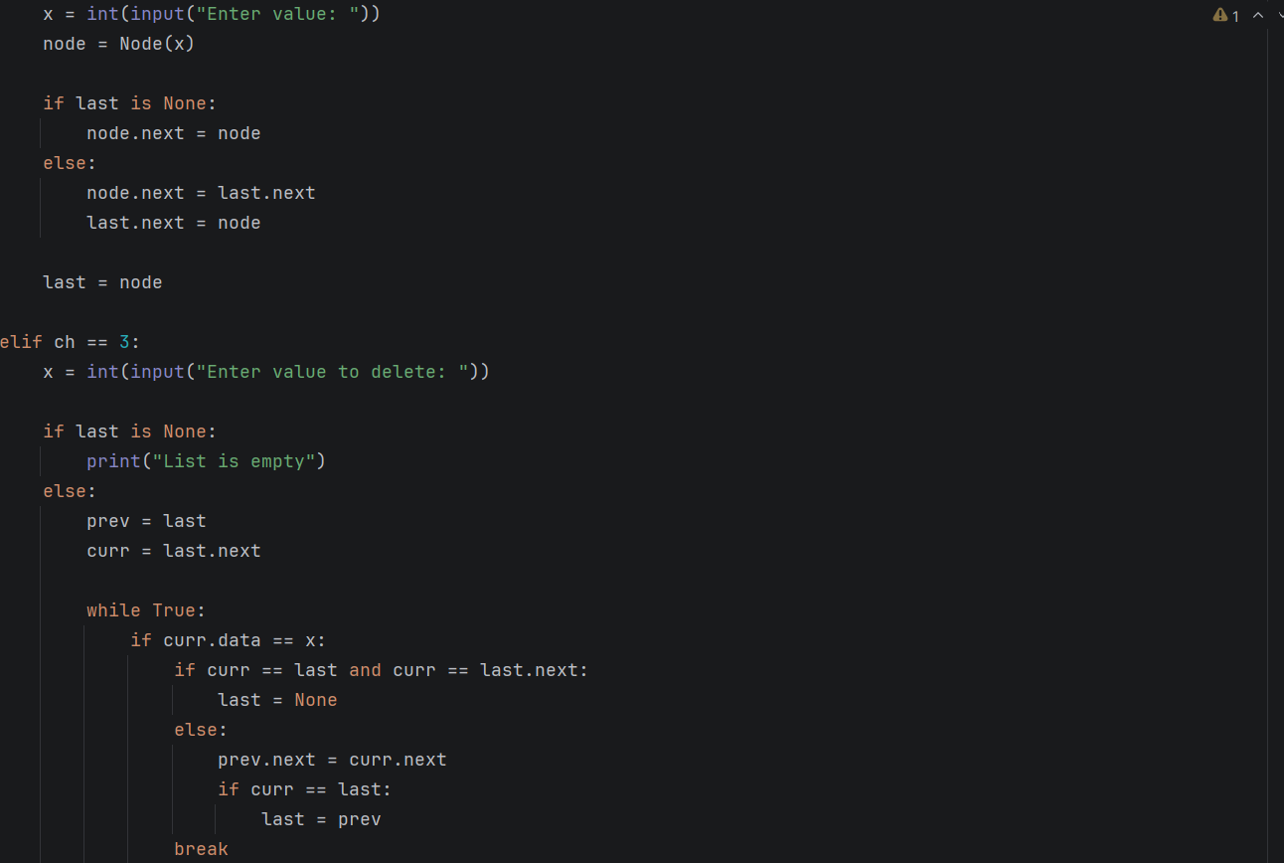

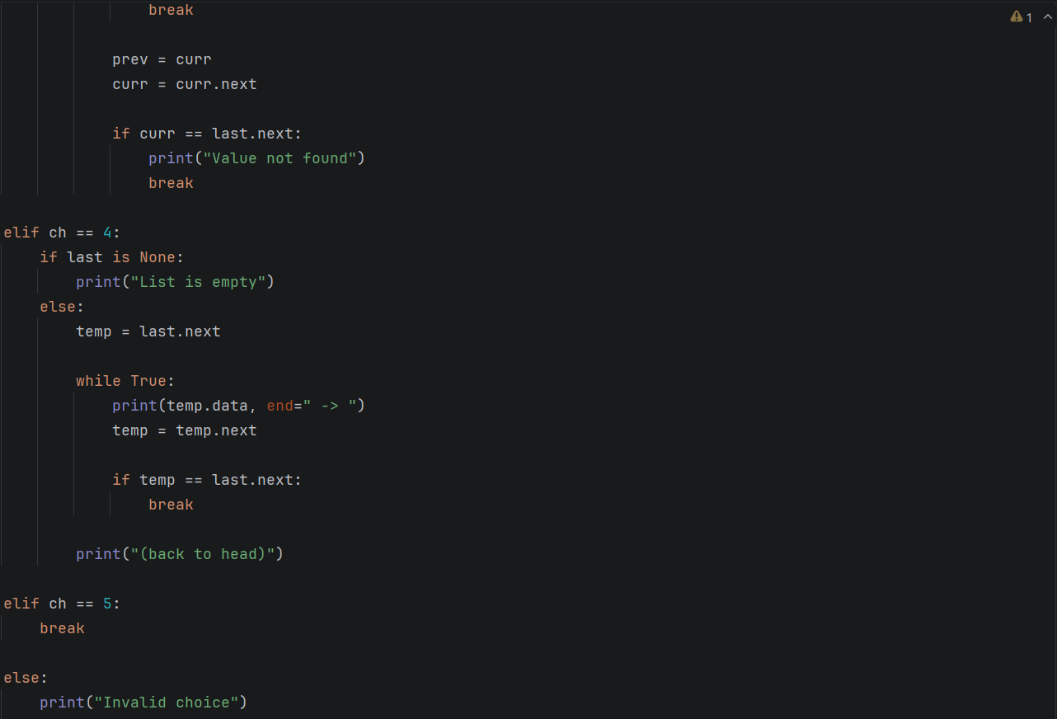

Output:
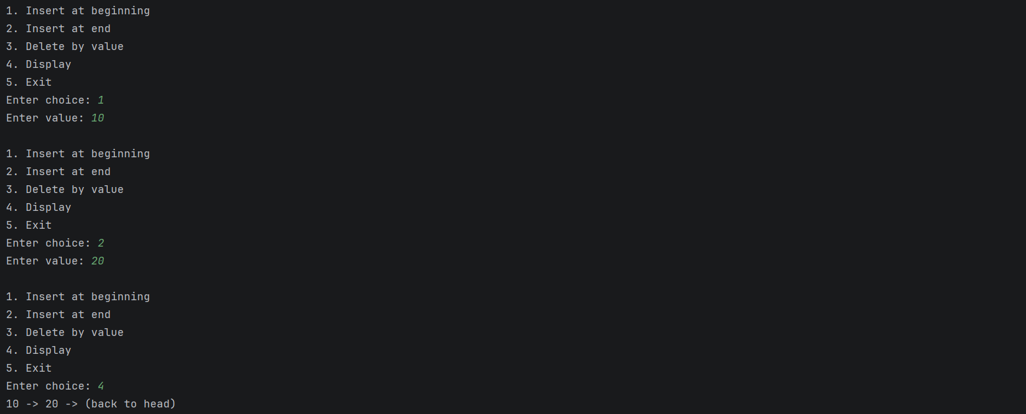
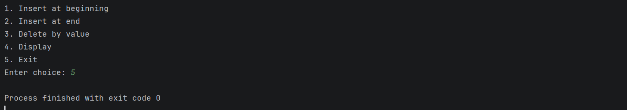

Practical 8: Stack, Queue and Circular Queue Using Linked Lists
Aim
To implement a stack, a queue and a circular queue using linked lists.

Algorithm

A. Stack using a linked list (top = None initially)
- Push: create a node, set node.next = top and top = node.
- Pop: if top is None, report Stack Underflow; otherwise read top.data, set top = top.next and return the item.
- Peek: if top is None, report underflow; otherwise return top.data.
- Display: traverse from top and print each node.

B. Queue using a linked list (front = rear = None initially)
- Enqueue: create a node. If the queue is empty, set front = rear = node; otherwise set rear.next = node and rear = node.
- Dequeue: if front is None, report Queue Underflow. Otherwise read front.data and set front = front.next; if front becomes None, also set rear = None.
- Front: if the queue is empty, report underflow; otherwise return front.data.
- Display: traverse from front to rear and print each node.

C. Circular queue using a linked list (front = rear = None initially)
- Enqueue: create a node. If the queue is empty, set front = rear = node and node.next = node. Otherwise set node.next = front, rear.next = node and rear = node.
- Dequeue: if the queue is empty, report underflow. If front is rear (one node), set both to None. Otherwise set front = front.next and rear.next = front.
- Front: if the queue is empty, report underflow; otherwise return front.data.
- Display: start at front, print each node and stop when front is reached again.

Output:
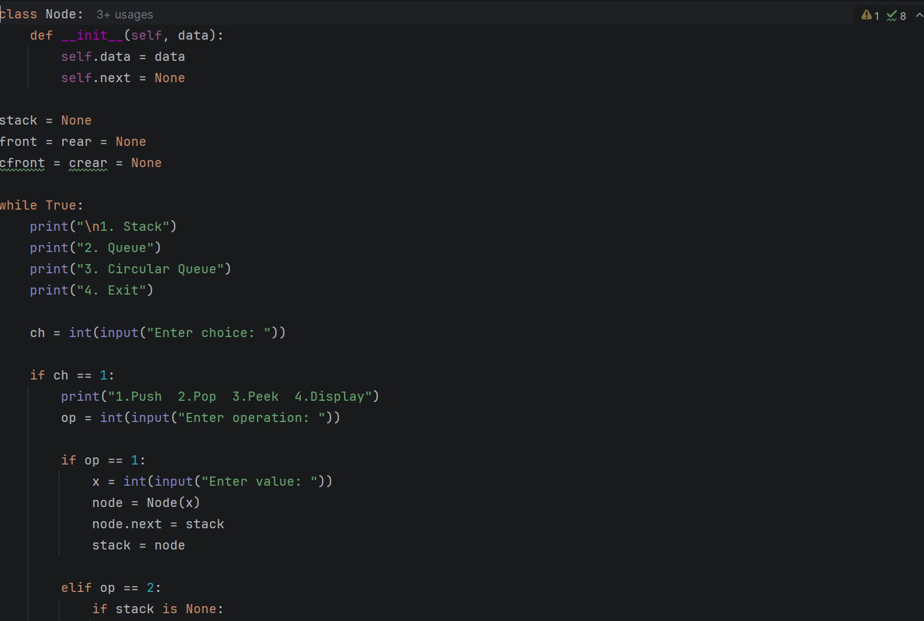

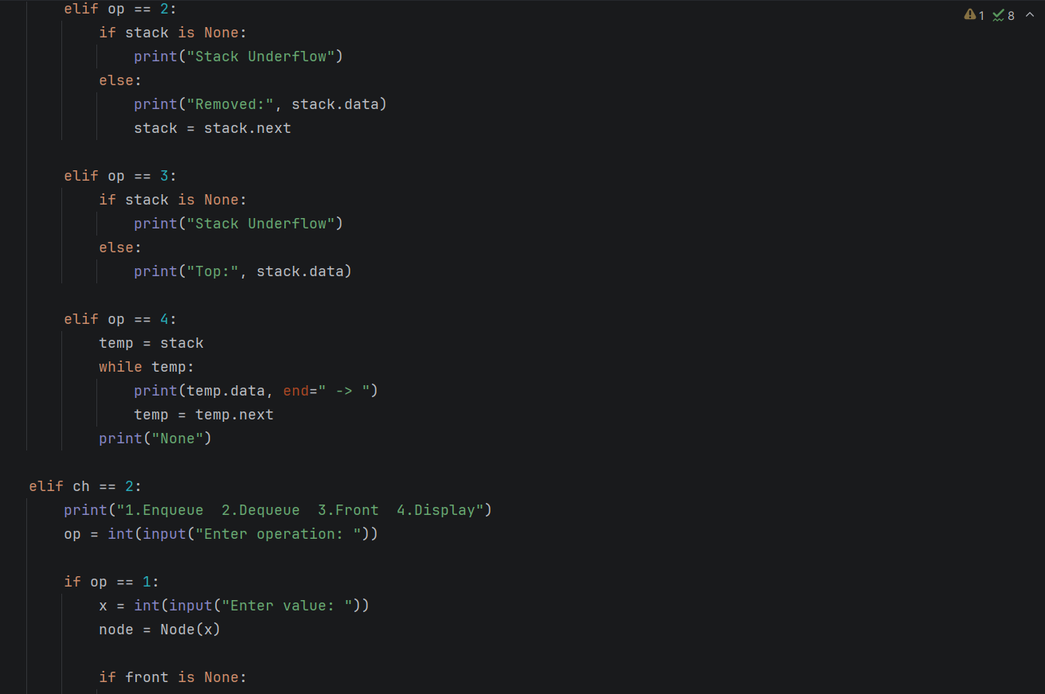
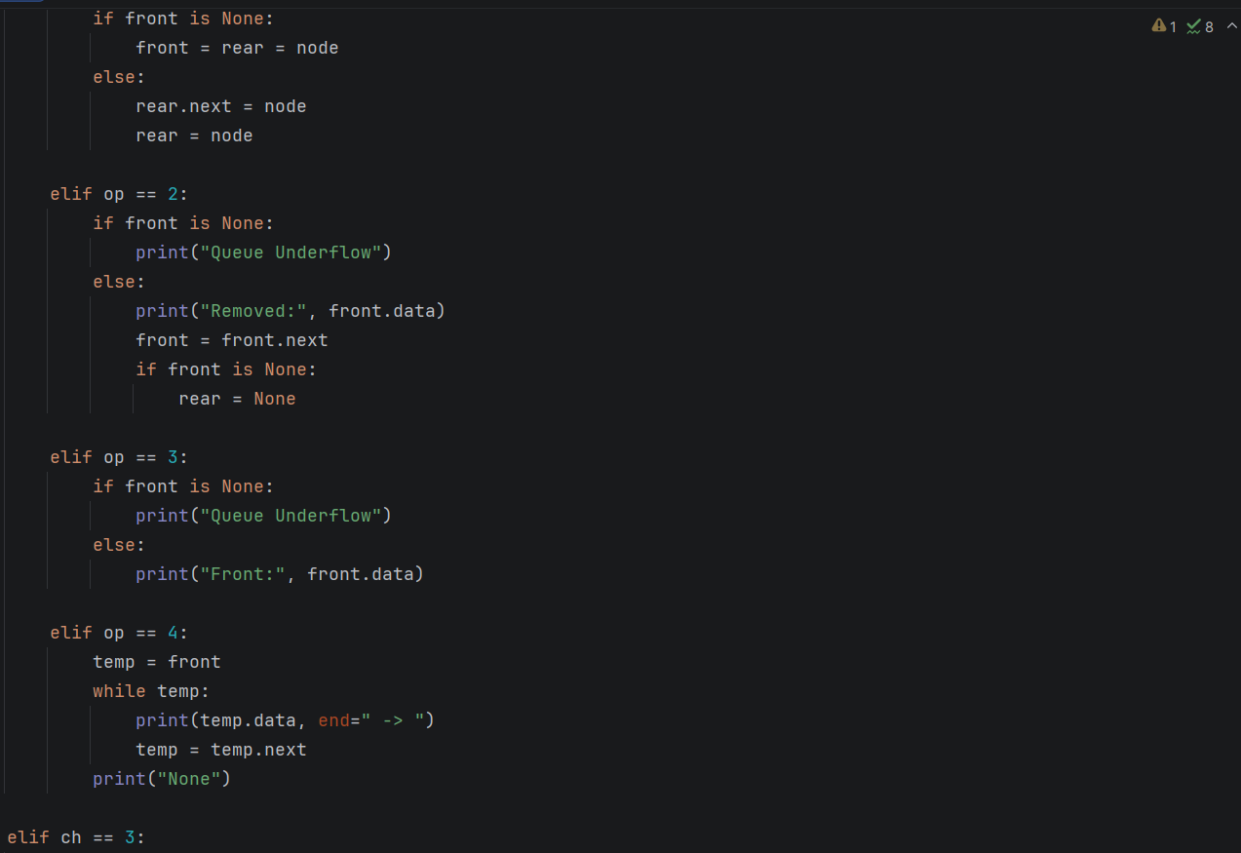
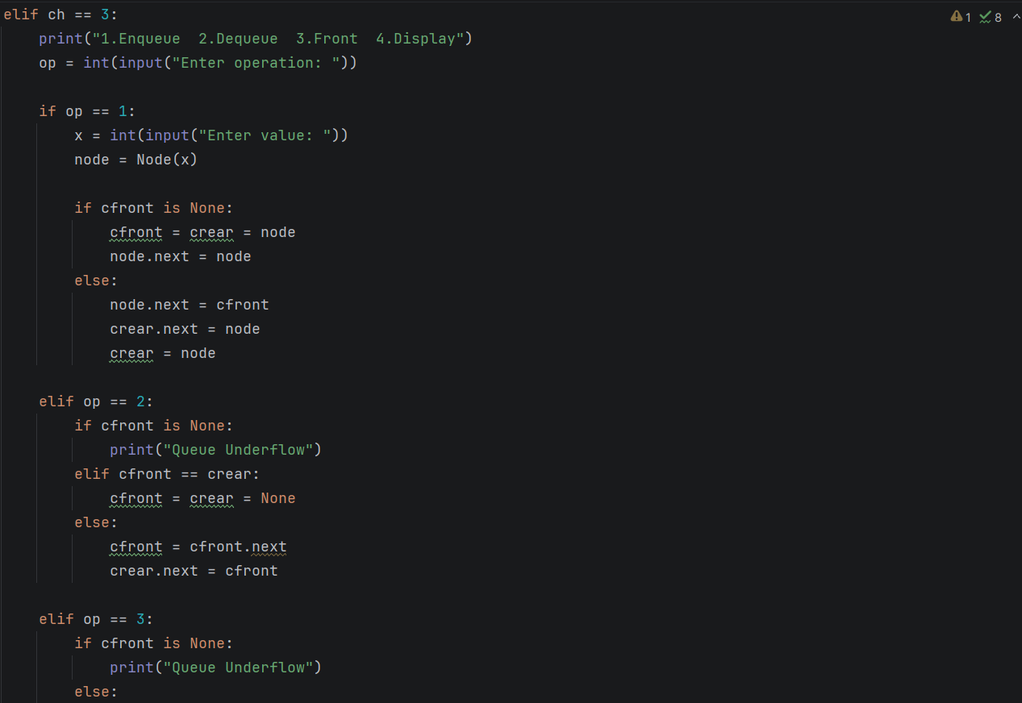
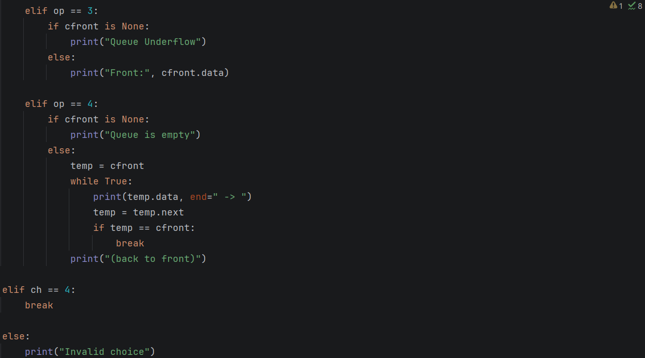

Output:
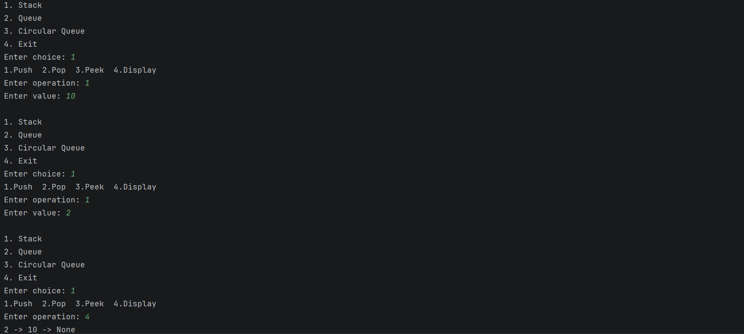

Practical 9: Linked List Concatenation and Polynomial Addition

Aim
To write Python programs that concatenate two linked lists and that represent and add polynomials using linked lists.

Algorithm

A. Concatenation of two linked lists
- Read the elements of the two lists and create two singly linked lists. Display both lists.
- If list 2 is empty, stop: list 1 is unchanged.
- If list 1 is empty, set head1 = head2.
- Otherwise traverse list 1 to its last node and set last.next = head2.
- Set head2 = None (the nodes now belong to list 1) and display the concatenated list.

B. Polynomial representation and addition
- Read the terms of each polynomial as coeff exp pairs. For every pair with a non-zero coefficient, insert a node in descending order of exponent; if a node with the same exponent exists, add the coefficients and delete the node if the sum is zero.
- Set pointers a and b to the first terms of the two polynomials.
- While a or b is not None: if a.exp > b.exp copy the term of a and advance a; if b.exp > a.exp copy the term of b and advance b; if the exponents are equal, add the coefficients and advance both pointers.
- Append a new node to the result for every term whose coefficient is not zero.
- Display both input polynomials and the sum. An empty result is displayed as 0.

Python Program:

A. Concatenation of Two Linked Lists:

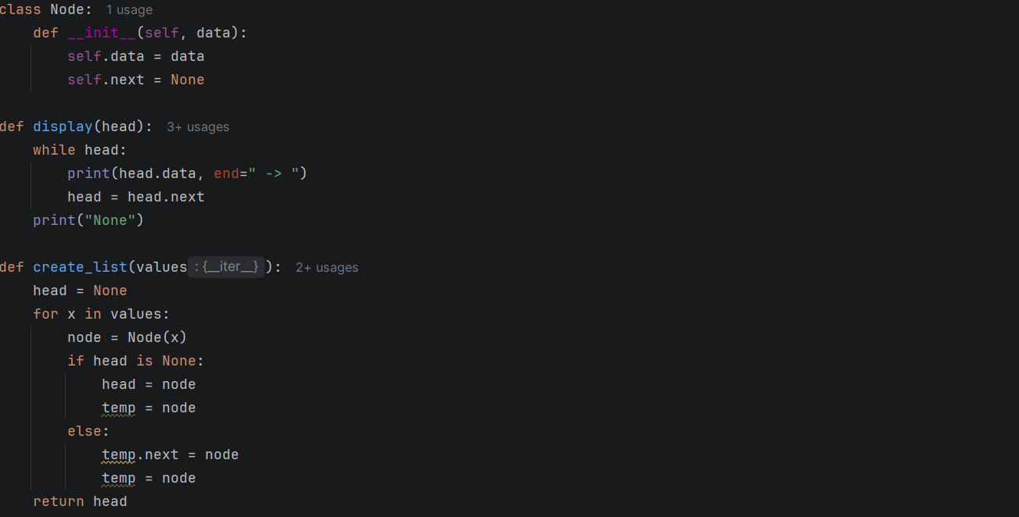

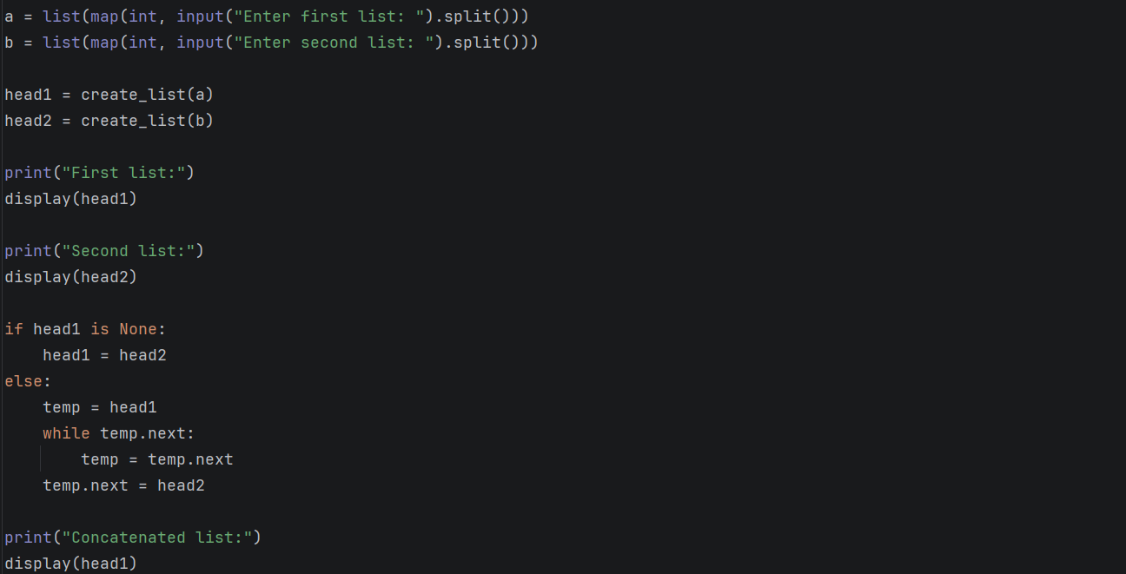

Output:

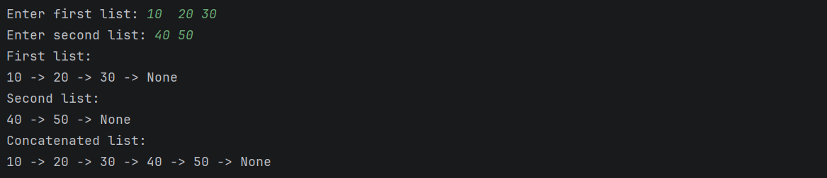

B. Polynomial Representation and Addition

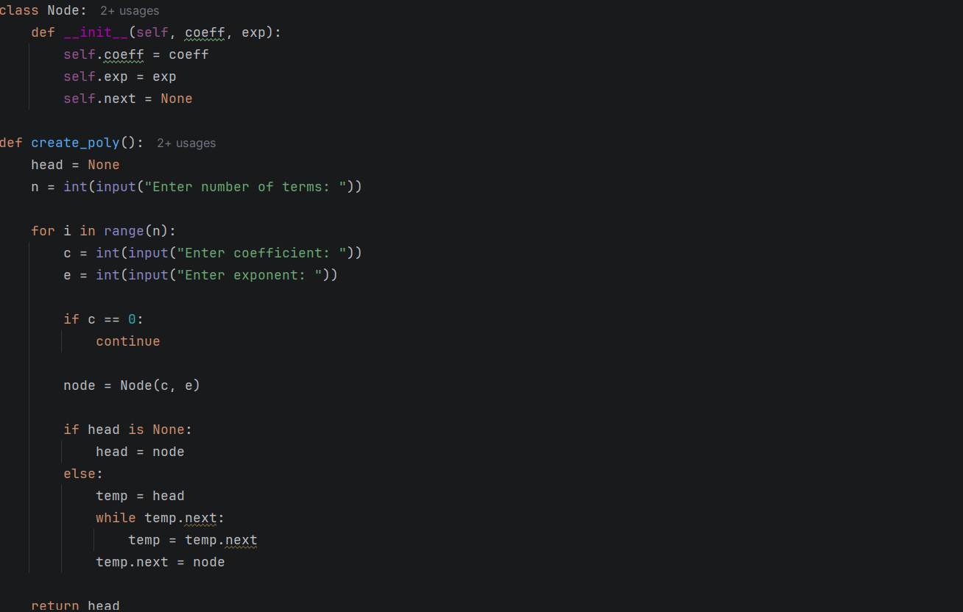

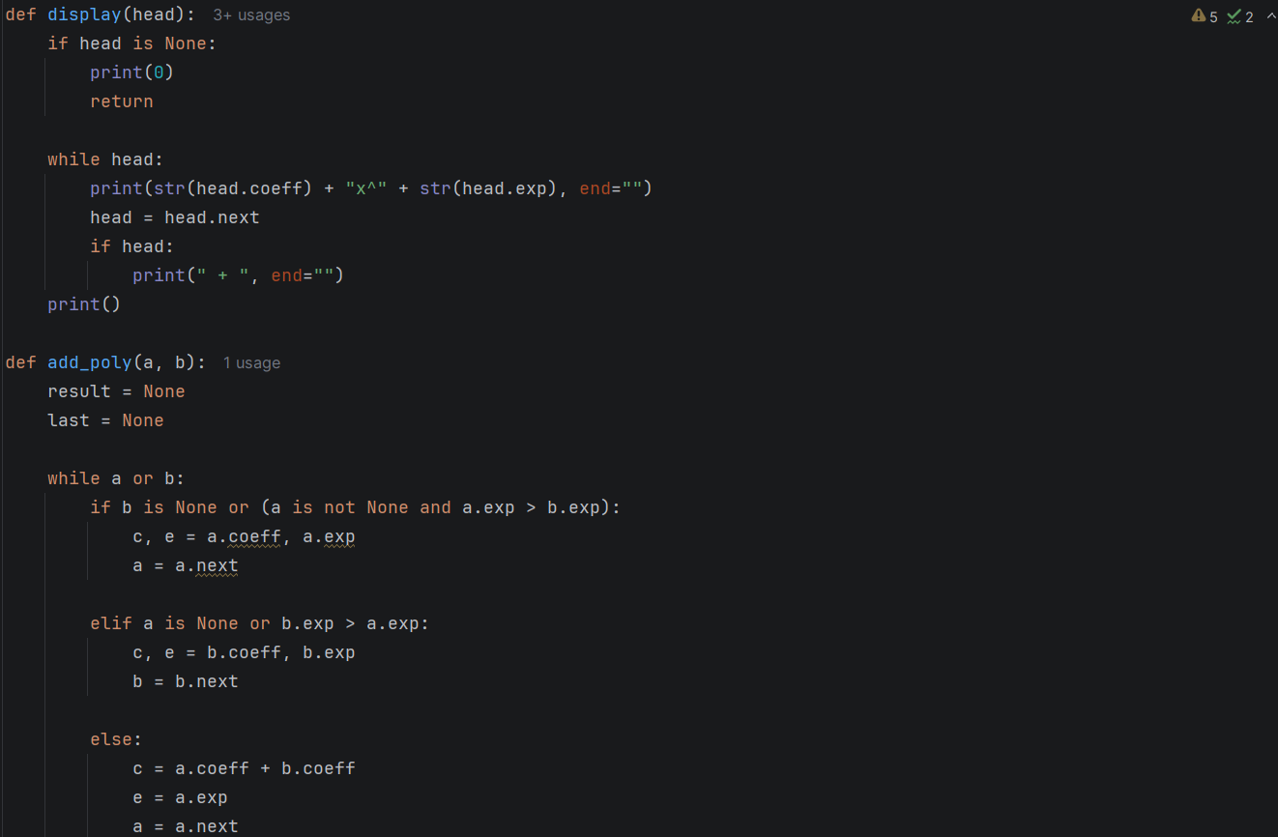

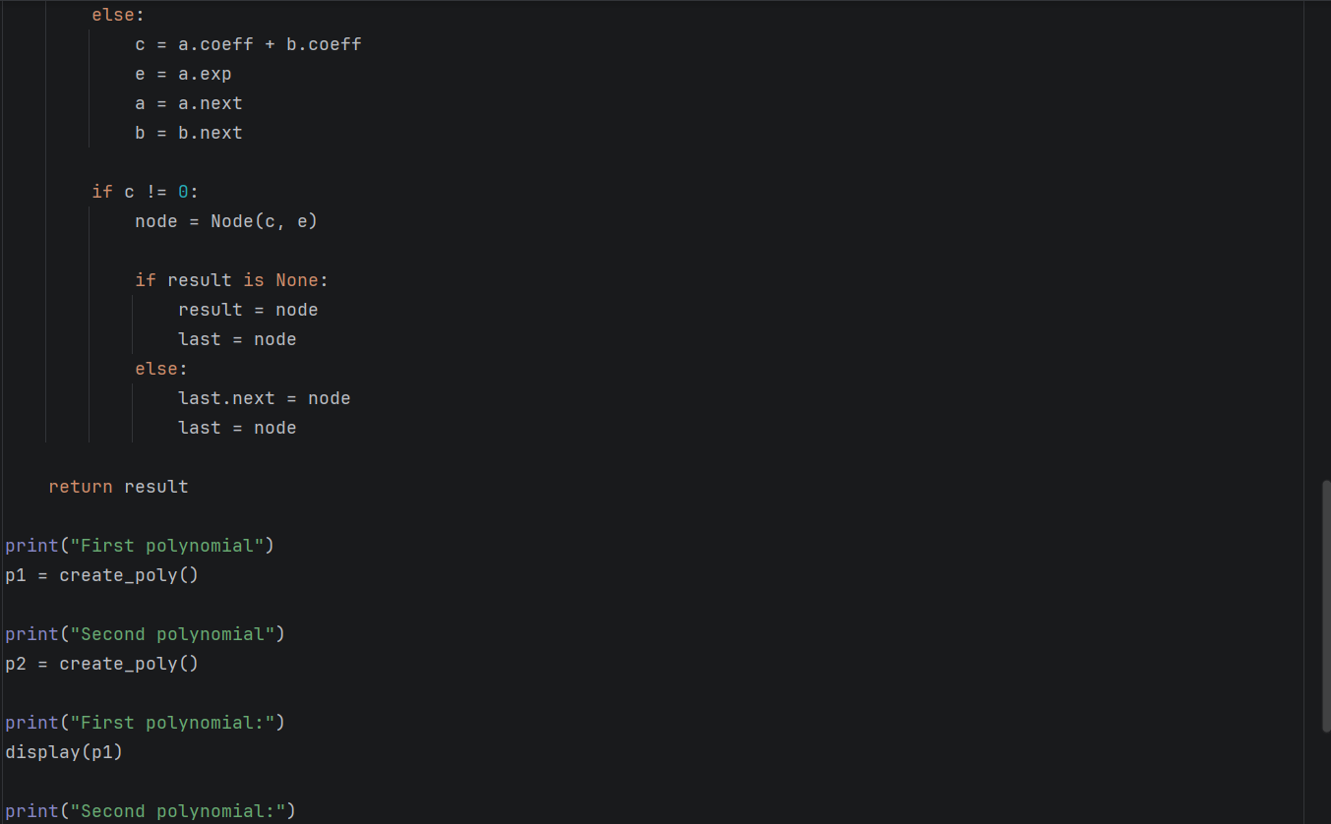

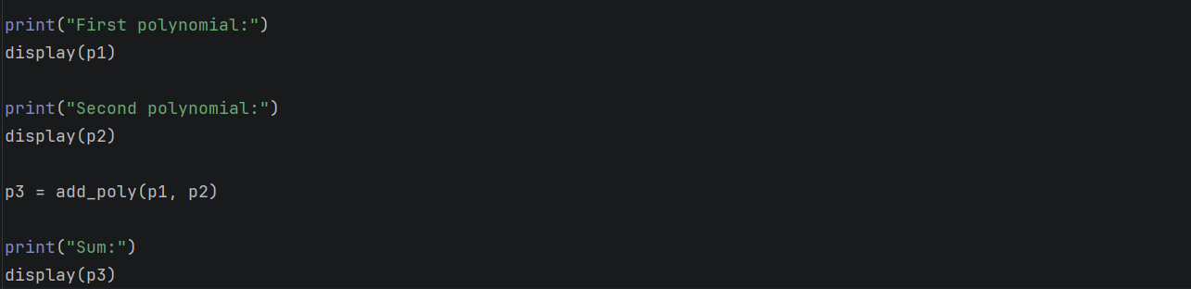

Output:
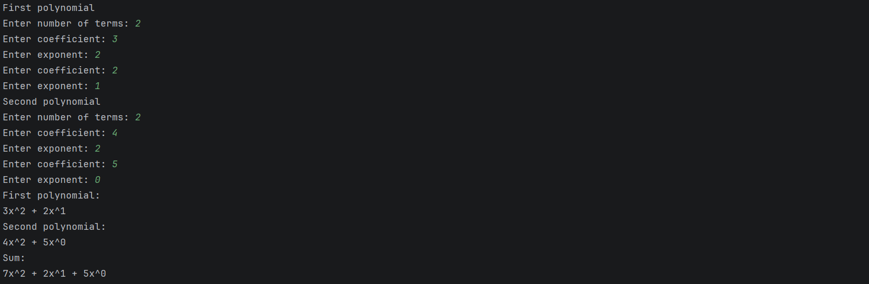

Practical 10: Doubly Linked List Operations

Aim
To write a Python program that performs insertion, deletion and display operations on a doubly linked list.

Algorithm
- Create an empty list with head = tail = None.
- Insert at beginning: create a node. If the list is empty, set head = tail = node. Otherwise set node.next = head, head.prev = node and head = node.
- Insert at end: create a node. If the list is empty, set head = tail = node. Otherwise set node.prev = tail, tail.next = node and tail = node.
- Delete by value: traverse from head to find the node current holding the value. If it is not found, report it.
- If current.prev exists, set current.prev.next = current.next; otherwise current is the first node, so set head = current.next.
- If current.next exists, set current.next.prev = current.prev; otherwise current is the last node, so set tail = current.prev.
- Display: if the list is empty, report it. Otherwise traverse from head using next for the forward display, and from tail using prev for the reverse display.

Python Program
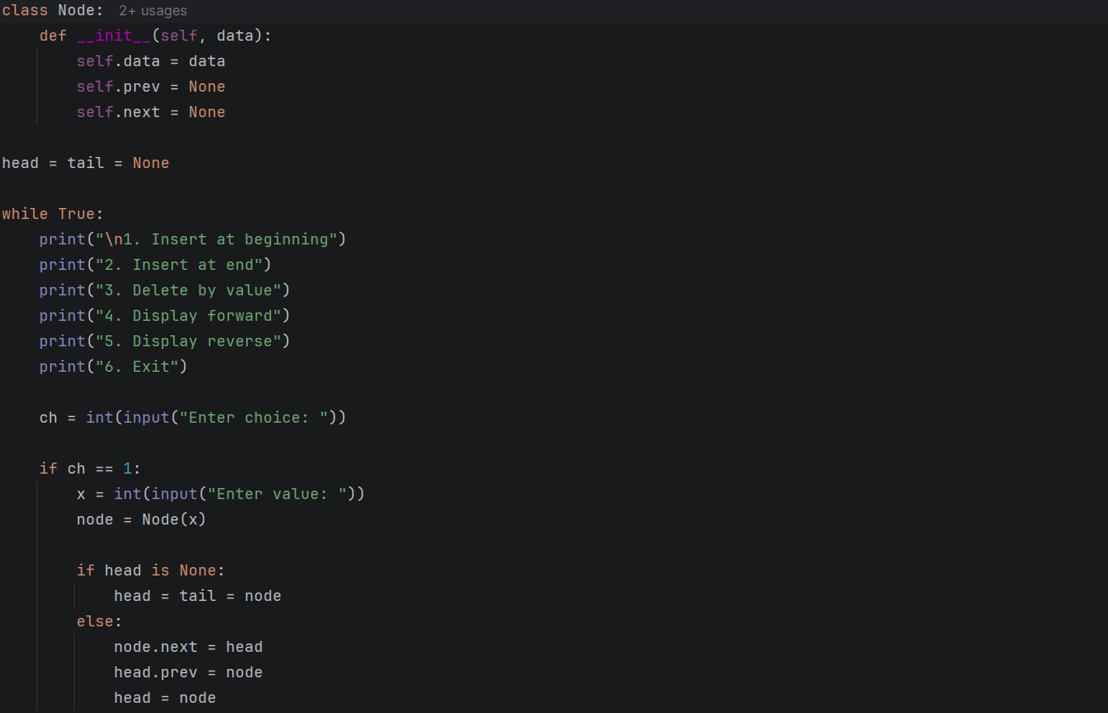
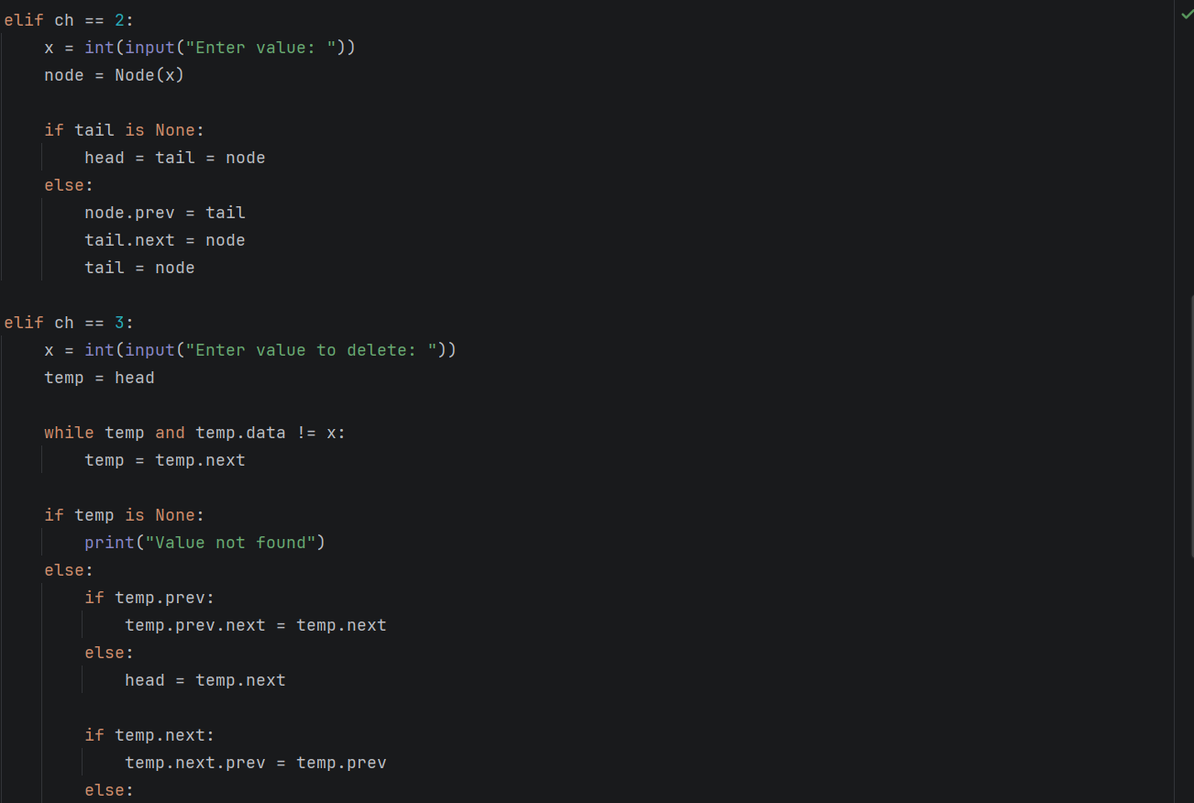
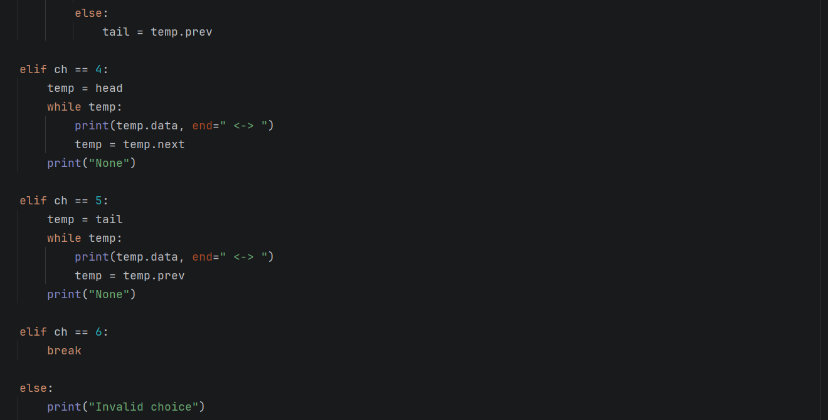

Output:

